**Installation and Documentation**

Programming Language: Python

Framework: Appium

IDE: PyCharm

Packages: Appium-Python-Client 2.6.1

Tools: Android Studio, Appium Desktop,pytest

Emulator Platform: Android 5.1

Real Device Platform: Android 11

**Task: Write test scripts to automate mobile devices suing Appium**

**Task Details:**

Send “Good Morning” sms from Device 1 to Device 2 .  
It must be the same sms received at the receiver end and  
Must be in the same conversation thread.  
It Must open the Message app  
Must show that its tapping on conversation  
Must show that its typing the text: Good Morning  
And Must show its sending.

**Steps to execute test scripts**

**1.Install Android Studio, PyCharm and Appium Desktop App**

**2.Install the required decencies and package (i.e.: Appium-Python-Client 2.6.1)**

**3.Make an emulator device in android studio of android version 5.1**

**4.Run s Appium Server through Appium Desktop App**

**5.Finally run the test scripts from the pycharm IDE**

**Task 1: ScreenSot**

**Source Code:**

import pytest  
def testcreenShot():  
 # importing the required packages and modules  
 from appium import webdriver  
 from selenium.webdriver.common.by import By  
 import os  
 from appium.common.logger import logger  
  
 # defining desired Capabilites  
 desired_capabilities = {}  
 desired_capabilities['deviceName'] = 'emulator-5554'  
 desired_capabilities['platformName'] = 'Android'  
 desired_capabilities['appPackage'] = 'com.android.mms'  
 desired_capabilities['appActivity'] = 'com.android.mms.ui.ComposeMessageActivity'  
  
 # establising connection with appium desktop server  
 driver = webdriver.Remote("http://localhost:4723/wd/hub", desired_capabilities)  
  
 # filename of screenshot  
 file_name = 'screenshot.png'  
  
 # taking screenshot  
 driver.save_screenshot("D:/freelance/pytest/Mobile Automation/Screenshots/" + file_name)

**Output:**

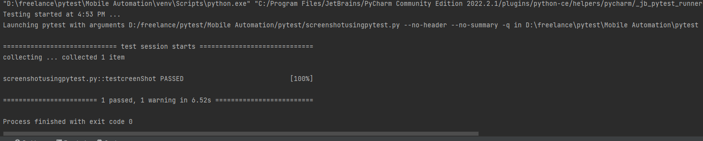

**Note: ScreenShot will be saved in Screenshot folder**

**Task 2: Send SMS**

**Source Code:**

import pytest  
def testsendsms():  
 # importing modules and packages  
 from appium import webdriver  
 from selenium.webdriver.common.by import By  
 # list of desired capabilities  
 desired_capabilities = {  
 "deviceName": "emulator-5554",  
 "platformName": "Android",  
 "automationName": "uiautomator2",  
 "appPackage": "com.android.mms",  
 "appActivity": "com.android.mms.ui.ComposeMessageActivity"  
 }  
 # conneting with appium server  
 driver = webdriver.Remote("http://localhost:4723/wd/hub", desired_capabilities)  
  
 # findind elements and automating  
 driver.find_element(By.ID, 'com.android.mms:id/recipients_editor').send_keys('98404409049')  
 driver.find_element(By.ID, 'com.android.mms:id/embedded_text_editor').send_keys('Good Morning')  
 driver.find_element(By.ID, 'com.android.mms:id/send_button_sms').click()  
 driver.quit()  
  
 # exit

**Output:**

